

**A REPORT ON SUMMER INTERNSHIP**

**Name of the Student : Alekya Mantri**

**Name of the College :** Vignan’s Institute of Information Technology

**Registration Number :** 22L31A4330

**Period of Internship :** 4 weeks

**From :** 23/04/2024 to 22/05/2024

**Year :** 3rd Year

**Name and Address of the Intern Organization:** TechnoHacks EduTech,Nashik,Maharashtra

**An Internship Report on**

**WEB DEVELOPMENT SUMMER INTERNSHIP**

*Submitted in accordance with the requirement for the degree of*

#### Bachelor of Technology

By

**Alekya Mantri  
22L31A4330**

Under the Guidance of

Mrs. B. Pavani



**DEPARTMENT OF ADVANCED COMPUTER SCIENCE & ENGINEERING**

**May 2024**

# C:\Users\12043\Desktop\LOGO.png

**DEPARTMENT OF ADVANCED COMPUTER SCIENCE & ENGINEERING**

**May 2024**

# DECLARATION

I, Alekya Mantri Reg. No **:** 22L31A4330**,** of the Department OF **Computer Science and Engineering- Artificial Intelligence** do hereby declare that I have completed the mandatory internship from TechnoHacks EduTechunder the Faculty Guideship of Mrs. B. Pavani , Department of Computer Science and Engineering**-** Artificial IntelligenceVignan’s Institute of Information Technology.

Signature of the Student

**CERTIFICATE**

This is to certify that Alekya Mantri Reg. No.22L31A4330 has completed her Internship in TechnoHacks EduTech under my supervision as a part of partial fulfillment of the requirement for the Degree of in the Department of Computer Science and Engineering, Vignan’s Institute of Information Technology. This is accepted for evaluation.

**Head of the department Signature of Guide**

Mrs. K. Swathi Mrs. B. Pavani

Assistant Professor

# CERTIFICATE FROM INTERN ORGANIZATION

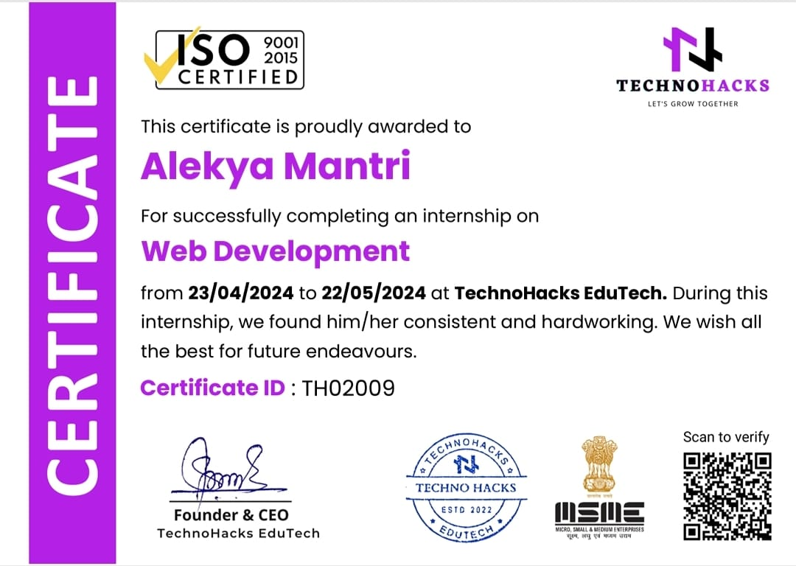

## Acknowledgements

I would like to express my sincere appreciation for the opportunity to complete my internship as a web developer at TechnoHacks EduTech from 23/04/2024 to 22/05/2024. I am also grateful to Vignan's Institute of Information Technology for providing me with the necessary skills and knowledge that laid the foundation for this enriching experience. I am deeply grateful to the faculty coordinator Mrs. B. Pavani for support and guidance throughout my internship.

## CONTENTS

|  |  |  |
| --- | --- | --- |
| **S. No.** | **Particulars** | **Page. No.** |
| 1 | Personal details |  |
| 2 | Title |  |
| 3 | Declaration |  |
| 4 | Certificate from intern organization |  |
| 5 | Acknowledgement |  |
| 6 | Contents |  |
| 7 | Chapter-1: Executive Summary |  |
| 8 | Activity Log for Week-1 |  |
| 9 | Weekly Report for Week-1 |  |
| 10 | Activity Log for Week-2 |  |
| 11 | Weekly Report for Week-2 |  |
| 12 | Outcomes Description |  |
| 13 | Daily Activity Photos |  |

### CHAPTER 1: EXECUTIVE SUMMARY

This internship report provides an overview of my internship experience as a web developer intern specializing at TechnoHacks EduTech The report highlights the learning objectives and outcomes achieved and summarizes the activities performed during the internship period.

#### Learning Objectives and Outcomes:

1. **Front-End Development:** Build expertise in HTML, CSS, and JavaScript to create responsive, interactive, and user-friendly web interfaces.
2. **Responsive Design:** Understand how to create layouts that adapt seamlessly to different screen sizes, ensuring a great user experience on mobile, tablet, and desktop devices.
3. **Problem-Solving Skills:** Apply your theoretical knowledge to practical challenges, improving your ability to solve real-world web development problems effectively.
4. **Project Management:** Develop the skills needed to plan, organize, and execute web development projects from the initial concept to final delivery.
5. **Debugging and Testing:** Build expertise in identifying and fixing bugs in your code while ensuring the functionality and quality of web applications.

**Internship Organization:**

TechnoHacks EduTech, a division of TechnoHacks Solutions Pvt. Ltd., has emerged as a leading organization in the field of IT training and education. Based in Nashik, Maharashtra, TechnoHacks EduTech has carved a niche for itself by providing comprehensive, industry-focused learning solutions aimed at bridging the gap between theoretical education and practical application.

TechnoHacks EduTech offers an extensive range of training courses designed to meet current industry demands. These courses include topics such as front-end development, data science, cloud computing, artificial intelligence, and more. With a focus on practical learning, students are exposed to real-world challenges and projects, which enhances their understanding and builds their confidence to tackle future roles.

The training methodology emphasizes hands-on experience under the guidance of seasoned professionals. Learners gain insights into real-world scenarios, enabling them to understand and apply theoretical concepts effectively.

TechnoHacks EduTech has gained the trust of students, professionals, and organizations through its commitment to quality education and exceptional results. By focusing on job-oriented training, the organization has enabled countless learners to secure fulfilling roles in the IT industry.

One of the distinguishing features of TechnoHacks EduTech is its robust placement support. The organization goes the extra mile to ensure that students are job-ready by providing career counseling, resume building, and interview preparation. Additionally, internships offered by TechnoHacks EduTech provide learners with invaluable exposure to industry environments.

TechnoHacks also prioritizes inclusivity and accessibility in education by incorporating flexible learning modules, including online and hybrid formats, to accommodate learners across various demographics.

### CHAPTER 2: ACTIVITY LOG FOR WEEK-1

|  |  |  |  |
| --- | --- | --- | --- |
| **Day** | **Date** | **Brief description of the**  **daily activity** | **Learning Outcome** |
| Day-1 | 23/04/2024 | Understood project requirements and set up tools | Learned about project objectives and tools setup |
| Day-2 | 24/04/2024 | Designed the basic structure for the calculator | Improved understanding of HTML and CSS fundamentals |
| Day-3 | 25/04/2024 | Implemented calculator functionality using JavaScript | Enhanced JavaScript skills for dynamic functionality |
| Day-4 | 26/04/2024 | Tested and debugged the calculator application | Learned debugging techniques and optimization strategies |
| Day-5 | 27/04/2024 | Designed the layout for the registration form | Gained insights into creating responsive forms |
| Day -6 | 28/04/2024 | Implemented validation logic for the registration form | Improved knowledge of form validation and error handling |

**WEEKLY REPORT**

##### WEEK – 1 (From 23/04/2024 to 28/04/2024)

**Objective of the Activity Done:** To develop a functional calculator and a responsive registration form, focusing on coding, testing, and debugging.

##### Detailed Report:

Day 1: Familiarized with tools and project objectives. Planned tasks for the calculator and registration form.

Day 2: Created the basic structure of the calculator using HTML and CSS.

Day 3: Added dynamic functionality to the calculator using JavaScript.

Day 4: Debugged and optimized the calculator for smooth operation.

Day 5: Designed a user-friendly layout for the registration form.

Day 6: Implemented input validation techniques for robust form functionality.

**ACTIVITY LOG FOR WEEK-2**

|  |  |  |  |
| --- | --- | --- | --- |
| **Day** | **Date** | **Brief description of the**  **daily activity** | **Learning Outcome** |
| Day-7 | 29/04/2024 | Designed the wireframe for the currency converter | Learned about wireframing and content layout |
| Day-8 | 30/04/2024 | Developed the currency converter structure with HTML | Improved knowledge of semantic HTML |
| Day-9 | 01/05/2024 | Styled the currency converter using CSS | Gained experience with CSS animations and transitions |
| Day-10 | 02/05/2024 | Added interactivity to the currency converter using JavaScript | Enhanced JavaScript skills for user interaction |
| Day-11 | 03/05/2024 | Tested the currency converter for responsiveness | Improved testing and debugging skills |
| Day-12 | 04/05/2024 | Reviewed and refined the currency converter | Learned the importance of quality assurance |

**WEEKLY REPORT**

##### WEEK – 2 (From Date: 29/04/2024 to Date: 04/05/2024)

**Objective of the Activity Done:** To design and implement an engaging landing page, focusing on layout, interactivity, and responsiveness.

##### Detailed Report:

Day 7 :Debugged the calculator and resolved performance issues.

Day 8: Created the structure of the currency converter using HTML.

Day 9: Styled the page with CSS, including animations and transitions.

Day 10: Added interactive elements using JavaScript.

Day 11: Tested the page for responsiveness and fixed layout issues.

Day 12: Conducted a comprehensive review and optimized the currency coverter.

**ACTIVITY LOG FOR WEEK-3**

|  |  |  |  |
| --- | --- | --- | --- |
| **Day** | **Date** | **Brief description of the**  **daily activity** | **Learning Outcome** |
| Day-13 | 05/05/2024 | Revised the calculator project and fixed issues | Improved debugging skills |
| Day-14 | 06/05/2024 | Optimized the registration form for responsiveness | Enhanced CSS knowledge for responsive design |
| Day-15 | 07/05/2024 | Added user feedback messages to the registration form | Improved JavaScript interaction skills |
| Day-16 | 08/05/2024 | * Worked on improving the currency converter aesthetics | Strengthened CSS design skills |
| Day-17 | 09/05/2024 | Performed cross-browser testing for all projects | Gained insights into browser compatibility issues |
| Day-18 | 10/05/2024 | Finalized and documented the completed projects | Learned project documentation best practices |

**WEEKLY REPORT**

##### WEEK – 3 (From Date:05/05/2024 to Date:10/05/2024)

**Objective of the Activity Done:** To review, improve, and finalize all projects while ensuring responsiveness and cross-browser compatibility.

##### Detailed Report:

Day 13: Familiarized with tools and project objectives. Planned tasks for the calculator and registration form.

Day 14: Made the registration form responsive for mobile and tablet devices.

Day 15: Added user feedback messages for invalid inputs in the registration form.

Day 16: Enhanced the landing page aesthetics with better color schemes and animations.

Day 17: Conducted cross-browser testing for all projects and resolved compatibility issues.

Day 18: Finalized all projects and documented them for submission.

**ACTIVITY LOG FOR WEEK-4**

|  |  |  |  |
| --- | --- | --- | --- |
| **Day** | **Date** | Brief description of the  Daily activity | Learning Outcome |
| Day-19 | 11/05/2024 | Prepared the portfolio showcasing all projects | Learned portfolio creation techniques |
| **Day-20** | 12/05/2024 | Reviewed project documentation and made updates | Enhanced attention to detail |
| Day-21 | 13/05/2024 | Attended final mentor feedback session | Gained valuable insights for improvement |
| Day-22 | 14/05/2024 | |  | | --- | | Made improvements based on feedback |  |  | | --- | |  | | Applied feedback effectively |
| Day-23 | 15/05/2024 | Prepared a presentation summarizing the internship | Improved presentation skills |
| Day-24 | 16/05/2024 | Submitted all projects and the final report | Learned submission process and final quality checks |

**WEEKLY REPORT**

##### WEEK – 4 ((From 11/05/2024 to 16/05/2024)

**Objective of the Activity Done:** To compile and showcase all projects, implement feedback, and prepare for final submission.

Detailed Report:

Day 19: Created a portfolio to showcase the calculator, registration form, and landing page projects.

Day 20: Reviewed and refined the project documentation for accuracy.

Day 21: Participated in a mentor session for final feedback and suggestions.

Day 22: Implemented changes based on mentor feedback to improve the projects.

Day 23: Prepared a presentation summarizing the projects, learning outcomes, and internship experience.

Day 24: Completed and submitted all deliverables, including projects and the final report.

**CHAPTER 3: OUTCOMES DESCRIPTION**

##### Describe the work environment you have experienced:

The work environment I experienced during my WordPress development internship was supportive and collaborative. I had the opportunity to interact closely with my mentor and guide, who were always available to assist me whenever I faced any challenges. Their guidance not only helped me resolve technical issues but also taught me the importance of approaching problems methodically and calmly. This mentorship was invaluable in helping me build confidence in my problem-solving abilities.

##### Describe the real time technical skills you have acquired:

##### Throughout the internship, I also learned the essential work ethics and discipline required in a professional setting. Being punctual, meeting deadlines, and maintaining a professional attitude were emphasized and practiced daily. This exposure was instrumental in understanding how to conduct oneself in a work environment, ensuring that tasks are completed efficiently and effectively. The structured environment provided a clear framework within which I could thrive and focus on my technical and professional development.

##### Describe how could you improve your communication skills:

In addition to the technical skills I acquired, the internship significantly enhanced my communication and leadership abilities. Regular interactions with team members, participating in discussions, and presenting my work helped me develop strong communication skills. I learned how to articulate my ideas clearly, listen actively, and provide constructive feedback. These experiences were crucial in building my confidence and ability to collaborate effectively with others.

##### Daily Activity Photos

